EDUCATION ONLINE

https://doi.org/10.28925/2617-5266/2024.91

# INTERACTIVE TECHNIQUES IN FOREIGN LANGUAGE LEARNING ONLINE IN NON-FORMAL EDUCATIONAL INSTITUTIONS

**IN CHINA**

**Liudmyla Gryzun**

ORCID ID 0000-0002-5274-5624

Doctor of science in Pedagogy,

Professor of the Information Systems Department

of Simon Kuznets Kharkiv National University of Economics. 9A Nauky Ave., Kharkiv, 61166, Ukraine,

[Lgr2007@ukr.net](mailto:Lgr2007@ukr.net)

**Caijing Zhang**

ORCID ID 0000-0002-8258-0015

Post-graduate student of the Department of Pedagogy, Philology and Translation of Simon Kuznets Kharkiv National University of Economics.

9A Nauky Ave., Kharkiv, 61166, Ukraine [zcj399489@163.com](mailto:zcj399489@163.com)

**ABSTRACT**

*The article treats the currently important issues of foreign language mastering in China and the challenges of online English learning in terms of non-formal institutions. It is revealed the urgency of the research associated with the problems of dropping students’ motivation to learn foreign language, and the lack of a classroom environment that facilitates interactive and communicative language practice, which causes the necessity to find out efficient means of the students’ involvement into the interactive and practically driven forms of work. Minding the great potential of existing blended learning activities and interactive techniques, there was undertaken the attempt to engage the students of Chinese non-formal institutions in innovative foreign language practices during online classes. According to the goals of the work, it is explored and elaborated on how interactive techniques can be applied to enhance typical blended learning activities in online English learning as a second language. This study also provides detailed examples of interactive methods applied in Chinese non-formal institutions in terms of typical online learning activities. Besides, it offers a preliminary analysis of the impact of these techniques on students' learning motivation. To get preliminary outcomes and test the prepared survey reliability, it was held in several groups of a Chinese private institution. In total 27 students of senior grades who learned English online in terms of implementation of various blended learning activities enhanced with interactive methods depicted above tool part in the survey. The acceptable reliability of the scales was proved. The outcomes of the survey, according to the levels of learners’ motivation are presented and discussed.*

***Keywords:*** *online foreign language learning, Chinese non-formal educational institutions, students’ engagement, interactive techniques, blended learning activities, motivation to learn.*

© Liudmyla Gryzun, Caijing Zhang, 2024

# INTRODUCTION

Online foreign language learning, particularly English, has seen substantial growth in China due to the increasing demand for English proficiency. Non-formal institutions, such as private language schools and online platforms, have become significant players in providing language education.

However, several challenges are associated with online English learning in these settings. Students often struggle with engagement, motivation, and the lack of a classroom environment that facilitates interactive and communicative language practice (Jiang et al., 2021; Zhou et al., 2020). The importance of interactive techniques in online learning cannot be overstated. These methods are crucial in enhancing blended learning activities such as flipped learning, digital storytelling, and gamification. Interactive techniques bring a classroom spirit to online classes, engaging students more effectively and motivating them to learn foreign languages. By integrating interactive techniques, educators can create a more dynamic and participative learning environment, which is essential for language acquisition. Thus, it is essential to find out the means of the students’ involvement into the interactive and practically driven forms of work.

Minding the great potential of existing blended learning activities and interactive techniques, we undertook the attempt to engage the students of Chinese non-formal institutions in innovative foreign language practices during online classes.

# RESEARCH OBJECTIVES

The purpose of this research is to explore and elaborate on how interactive techniques can be applied to enhance typical blended learning activities in online English learning as a second language. This study aims to provide examples of interactive methods applied in Chinese non-formal institutions and to offer a

preliminary analysis of the impact of these techniques on students' learning motivation. The paper is structured in the interconnected sections: introduction where the importance and purpose of the work are formulated; methodology and theoretical framework presenting the analysis of recent studies related to the topic and making the proper theoretical basis for the research; the section of results and discussion where the progress and deliverables of the work are highlighted and interpreted; conclusions

closing the paper.

# METHODOLOGY AND THEORETICAL FRAMEWORK

The theoretical framework of the research is made by the analysis of recent papers and other resources devoted to the: (1) main characteristics, problems and challenges of online English learning in Chinese non-formal (private) institutions; (2) typical learning techniques used in the practice of blended (online) learning like flipped learning strategy, gamification approach, digital storytelling, cooperative learning etc.;

(3) typical interactive techniques used in language learning (pair work, debates, mini-conferences, Socrative method, group language games, role-playing and others)

(4) basics of the theory of motivation to learning.

Based on the recent studies, there were analysed and revealed typical characteristics, problems, and challenges of online English (as a second language) learning in Chinese non-formal institutions. There are highlighted several challenging issues which should be minded in the current research.

The most urgent problem seems to be difficulties of the students’ engagement and retaining their motivation to learning. According to studies (Zhou et al., 2020; González et al., 2021), learners often feel isolated and less motivated in online classes compared to conventional physical classrooms. It is found out that learning in online environments can lead to dropping trainee’s engagement and motivation due to the lack of physical presence, peer interaction and collaboration. Additionally, the asynchronous nature of many online courses can result in students’ feeling disconnected from their instructors and peers.

Among problematic issues, there are also underlined technological barriers. In the

studies (Hui et al., 2019; Ren et al., 2024) are pointed out that despite technological advancements, problems like unstable internet connections and lack of access to necessary devices can prevent productive learning process. Technological barriers include not only hardware and software limitations but also trainees' varying levels of their digital literacy. In addition, it is noted that such problems could significantly impact students' ability to participate fully in online learning activities.

Quality of interaction also seems to be a challenging issue. It is argued by researchers (Jiang et al., 2021; Zhou et al., 2020), that the quality of interaction between peer-students and between students and teachers can be threatened, leading to less efficient language practice. In particular, it is said that while online platforms offer various tools for interaction, the absence of face-to-face communication can limit the forms, depth and quality of interaction and collaboration. This limitation can affect the development of speaking and listening skills, which are crucial for language mastering, and causes the search for additional techniques to improve the quality of interaction.

Next theoretical pillar of our work is the characteristics of typical learning techniques which are common in terms of online learning as a model of blended learning (Adel et al., 2021; Dellatola et al., 2020). According to studies, these techniques include flipped learning approach, gamification, cooperative learning, digital storytelling and others.

Flipped learning is recognized by educators as an approach where the typical classroom-based studying is inverted in the lines of encouraging trainees to acquire the certain content before the classroom time (either online or offline) (Adel et al., 2021; Dellatola et al., 2020). It also intends to involve students into reviewing or learning the content independently at home and engage them in various activities in class based on the mastered knowledge. Therefore, such an approach enables extended understanding of the pre-learned content through debating, discussions and problem-solving activities arranged by the teacher (Bergmann & Sams, 2012). In addition, this method encourages students to take responsibility for their learning and promotes deeper understanding through active participation. It is obvious though that its implementation takes special educators’ efforts to arrange and facilitate trainees’

interaction (effective feedback, question-answer sessions, collaborative problem-solving, etc.) during online classes.

One more methodology which is available in online and blended learning is gamification strategy. According to studies, it allows applying game-playing practices to non-game contexts and expects integrating game elements into learning can increase motivation and engagement. Game-based mechanisms and game thinking also enables to diversify learning, to raise students’ eagerness to learn and solve non-conventional tasks (Zainuddin et al., 2020).

It is highlighted that gamification strategies, such as point systems, leaderboards, and badges, can make learning more engaging and enjoyable (Dichev et al., 2017). These elements tap into students' intrinsic motivation by providing a sense of achievement and competition. Involving game elements into educational process provokes students’ essential needs for their motivation (for instance, their needs for communication and cooperation with others, feeling their expertise in a specific area, control of their actions and others). Therefore, gamification implementation enables to promote collaboration and facilitate interaction, which is significantly important for online synchronic learning.

Digital storytelling in common sense is a practice when people use some digital means to tell their narratives devoted to an urgent topic, presented in emotional way and focused on a special purpose, and then to share them with others. A digital story is understood as a multimedia presentation of a narrative that can be represented in various forms such as interactive stories, web-based video stories, narrative computer games and others (Sagri et al., 2018; Rutta et al., 2021).

The digital storytelling technique has been successfully introduced in educational practice. According to research, merging static or moving images, sounds and plot within a digital story is able to in hence concepts being beneficial for different learning types of learners. It is pointed out that digital storytelling can be used by educators with different didactic purposes: to introduce new learning material to facilitate its discussion by students, to help them get a deeper understanding of

complicated concepts (Sagri et al., 2018; Rutta et al., 2021).

In addition, students can be also encouraged to create their own digital stories devoted to some learning elements and pursuer a certain pedagogical aim. Such learning activity can provide important benefits for the students. Through the stories making, they have to analyse, synthesize, and to get ownership of the content they are presenting. These things stimulate higher-level thinking and raise responsibility. This activity can facilitate acquiring complicated (or controversial) academic material and receive certain research skills. Finally, created by the students, digital stories can be potentially used as efficient learning aids for other trainees.

In terms of languages learning, the said storytelling technique encourages students to create and share stories using digital tools, enhancing language skills through creative expression. Thus, this approach not only improves language skills but also fosters creativity and critical thinking.

Cooperative learning is also considered as one of the common techniques beneficial in terms of online learning. Students are involved into mutual work in groups to achieve certain learning goals, promoting interaction and collaboration. Cooperative learning enhances students’ engagement and achievement by encouraging peer-to-peer interaction and mutual support (Lemeshchenko-Lagoda & Kryvonos, 2020). This method also helps develop social and communication skills essential for language learning, and can be successfully used both in online and offline learning.

In terms of online cooperative learning where it is challenging to retain students’ motivation, it is really essential to engage them on practically meaningful work with the clear results. In this context, it is recommended to apply project-based learning (PBL) as a didactic strategy which makes students earn knowledge and work out skills via working upon projects focused on real-life problems (Dias et al., 2018; Le, 2018). As a result, the trainees are encouraged to apply deep knowledge, higher-order thinking abilities, critical thinking, communication and collaboration skills to successfully work as a team. In such a way, the language learning gets more alive and practically-driven for students. In addition, cooperative work on a real practical task can reveal a sort of contagious positive energy among students-peers and educators,

which is incredibly rewarding and essential, especially on conditions of physical disconnection which is inherent in online learning.

The theoretical background to ensure the high-quality PBL within our work is made by core guidelines providing essential project design elements as well as project-based teaching practices to help educators to improve, elaborate and assess their practice (Le, 2018; Rubrica, 2019; Trivedi et al., 2019).

Despite the said important advantages of reviewed techniques which are beneficial in terms of online learning, the researchers and practitioners point out the urgency of their enhancement with various interactive methods to raise these techniques efficiency and impact on students’ engagement.

Therefore, there were analysed the interactive techniques which are typically used in language (online and offline) learning and foster active participation and communication.

The most common method seems to be pair work when students practice language skills in pairs, facilitating conversational practice. According to studies, pair work allows for more speaking opportunities and helps students build confidence in using the language. This method also promotes peer learning, as students can correct and support each other (Lemeshchenko-Lagoda & Kryvonos, 2020).

One more interactive technique which is beneficial for developing speech habits is recognized as debates and mini-conferences. These activities encourage critical thinking and articulate expression. Based on (Lemeshchenko-Lagoda & Kryvonos, 2020; Chen, 2020), debates and mini-conferences provide a platform for students to practice argumentative skills and public speaking. These activities require students to research, organize their thoughts, and present their ideas logically and persuasively.

Socratic method which involves asking and answering questions to stimulate critical thinking and illuminate ideas is also recommended to be used in language learning. The Socratic method is described as a way to deepen understanding through dialogue and questioning. This technique encourages students to think critically and articulate their thoughts clearly, which stimulates students to work out their speech

habits (Paulet et al., 2006).

One of the popular activities in language classes is group language games and role-playing. These methods engage students in playful yet educational activities, enhancing their speaking and listening skills. In the papers (Chen, 2020; Wright et al., 2006), it is highlighted that language games and roleplaying activities create a fun and relaxed environment for language practice. These activities also encourage spontaneity and creativity in language use.

It can be summarized that the said interactive methods being used in terms of online learning should be adapted to the peculiarities of the blended learning techniques depicted above on purpose of raising students’ engagement and motivation to learning.

According to the fundamentals of motivation theory, motivation to learn is investigated by the experts from both psychological and educational dimensions. It is considered as a learner’s energy and drive to learn, study effectively and realize their inherent potential (Collie et al., 2019; Filgona et al., 2020; Li et al., 2020; Herpratiwi, 2022). It is also seen as the human efforts which provoke learning activities, ensure their continuity and focus the activities with the aim at gaining desired goals by a student (Filgona et al., 2020).

Motivation is also considered as a critical factor in language learning (Aljuaid, 2021). In particular, it is seen as a contributor to trainees’ achievements, progress of language mastering, enthusiasm in overcoming learning difficulties and retention in language non-formal education.

According to researchers (Li et al., 2020; Herpratiwi, 2022; Triarisanti, 2019), there are some common factors affecting motivation in the tutoring process: kept attention, appealing to learner’s experience, positive attitude to learning, and satisfaction. It is claimed that provision of these components of motivation during studying may promote and sustain trainee’s motivation to learn (Li et al., 2020; Herpratiwi, 2022). Based on other experts (Aljuaid, 2021; Batubara et al., 2020), very similar factors that influence on motivation to learn a foreign language include interest to learning, empowerment and usefulness of language mastering, success, and

satisfaction.

Therefore, it is possible to formulate some practical rules to be followed in the progress of language teaching to provide the said components (Aljuaid, 2021; Batubara et al., 2020). The first rule expects applying different learning strategies to provoke interest to language activities and attract trainees’ attention. The second rule recommends to give clear instructional goals and to focus trainees on the usefulness of language mastering in terms of their previous and potential experience. The third rule, prompts to create the learning environment which promotes their positive attitude to the learning and suggests focusing towards success. According to the fourth rule, it is essential to help students gain satisfactory feeling. Thus, teachers have to follow these rules in order to efficiently motivate students to study and master languages.

In addition, it is claimed that there are strong links between motivation and students’ engagement where interactivity plays an essential role, which is consistent well with the incentives for both internal and external motivation. It is underlined, that interactive forms of language mastering are able to demonstrate trainees the value of their personal participation in common discussion, to let them see the efficiency of their own contribution into productive team work, to feel excitement and pleasure, which finally can influence on their learning motivation.

# RESULTS AND DISCUSSION

The analysed theoretical basics were implemented to elaborate interactive techniques for enhancing different blended learning activities to raise students’ engagement and motivation to language learning.

In our educational practice there were implemented the following strategies and cases which illustrate how interactive techniques can enhance blended learning activities in online English learning.

Flipped learning can be enhanced with interactive discussions in the following way. After watching video lectures at home, students participate in online discussions and role-plays during live sessions. For instance, in a Tencent Meeting, Zoom (or other video-conference) class, the tutor can divide students into breakout rooms where they

role-play different scenarios related to the lecture content. In particular, after learning in advance grammar issues on the contrast of present perfect and past simple tenses, the students are involved into online role-playing the conversations “Have you been to…”. Where the students in small groups share their travelling impressions. The tutor’s mission is to provide the trainees with speech samples to support their discussion and point out the difference between the said tenses using.

After such an interactive work within small groups, each group representatives present their trips in the form of mini-conference where some students are presenters and some of them are listeners. All of them are encouraged by the instructor to take part in question-answer session.

In terms of flipped learning vocabulary patterns, role-playing in breakout rooms is also really beneficial. For example, the instructor assigns a role-playing activity where students practice ordering food at a restaurant. In breakout rooms, one student plays the role of the customer, and another plays the waiter. They use provided dialogue prompts and add their own variations. After the role-playing exercise, the class reconvenes, and each pair performs their dialogue. This activity provides a realistic context for language use and helps students practice conversational skills.

Thus, such a flipped learning approach enhanced with interactive methods stimulates students to actively use the language issues they have learned and apply it in real-life contexts. Interactive discussions and role-plays help students consolidate their understanding of the grammar points through peer teaching and develop speaking

-listening skills while promoting critical thinking and collaboration. In addition, it enables to reduce disconnection, add classroom spirit into online classes, and retain students’ interest. Some episodes of the said practices (see Fig. 1).

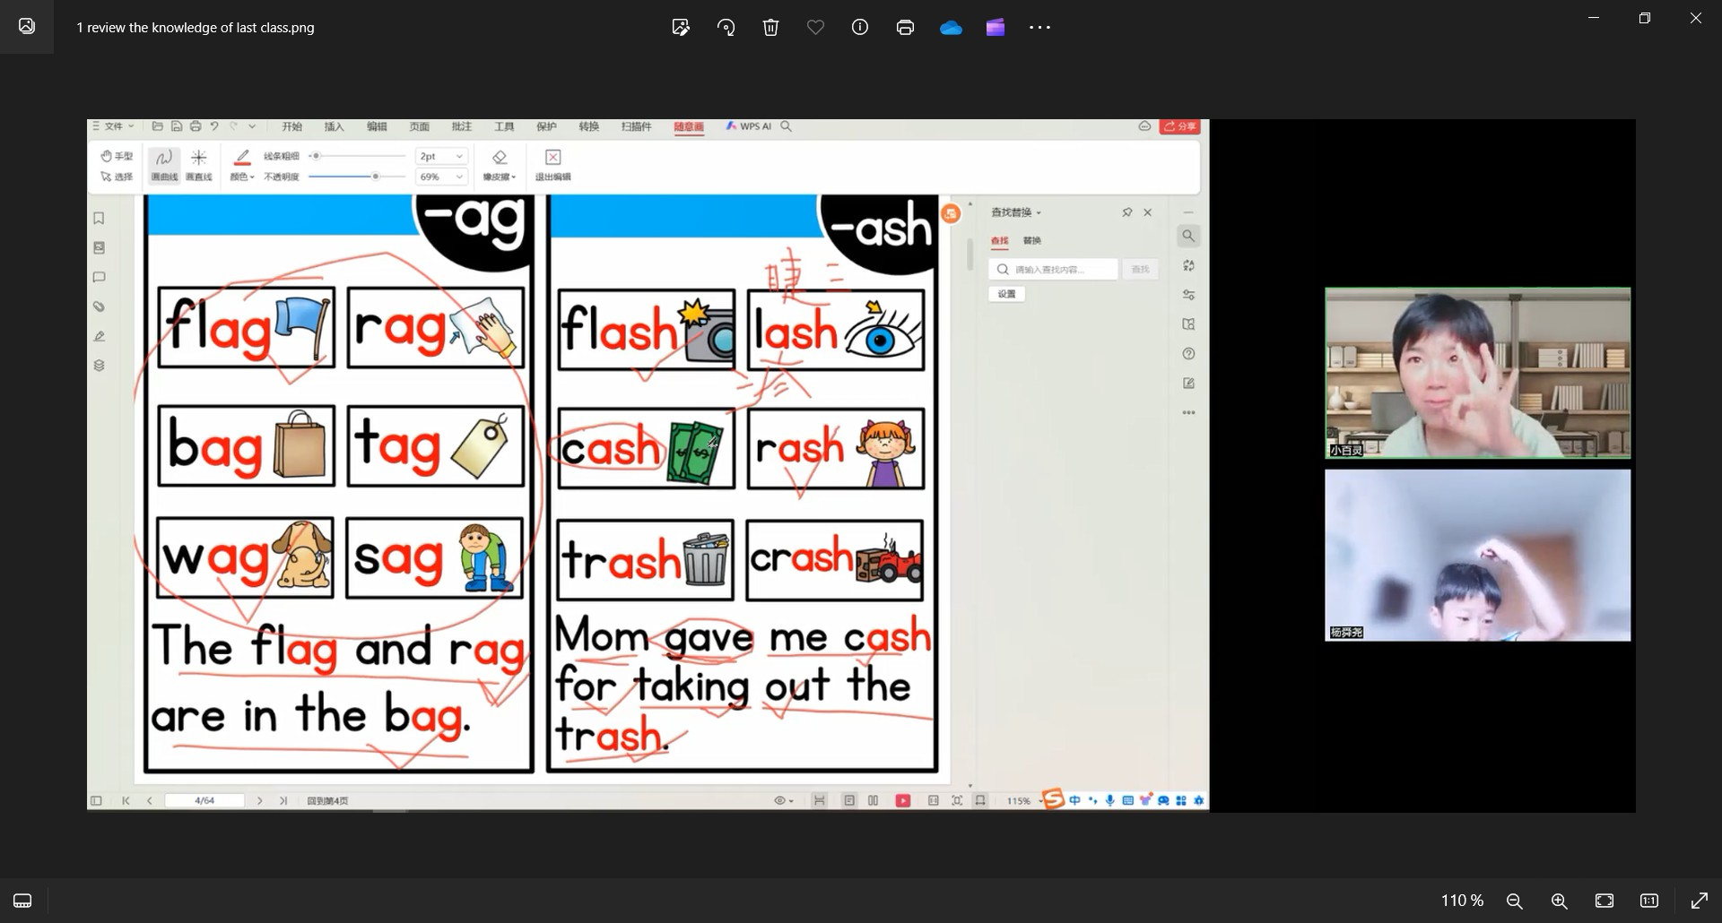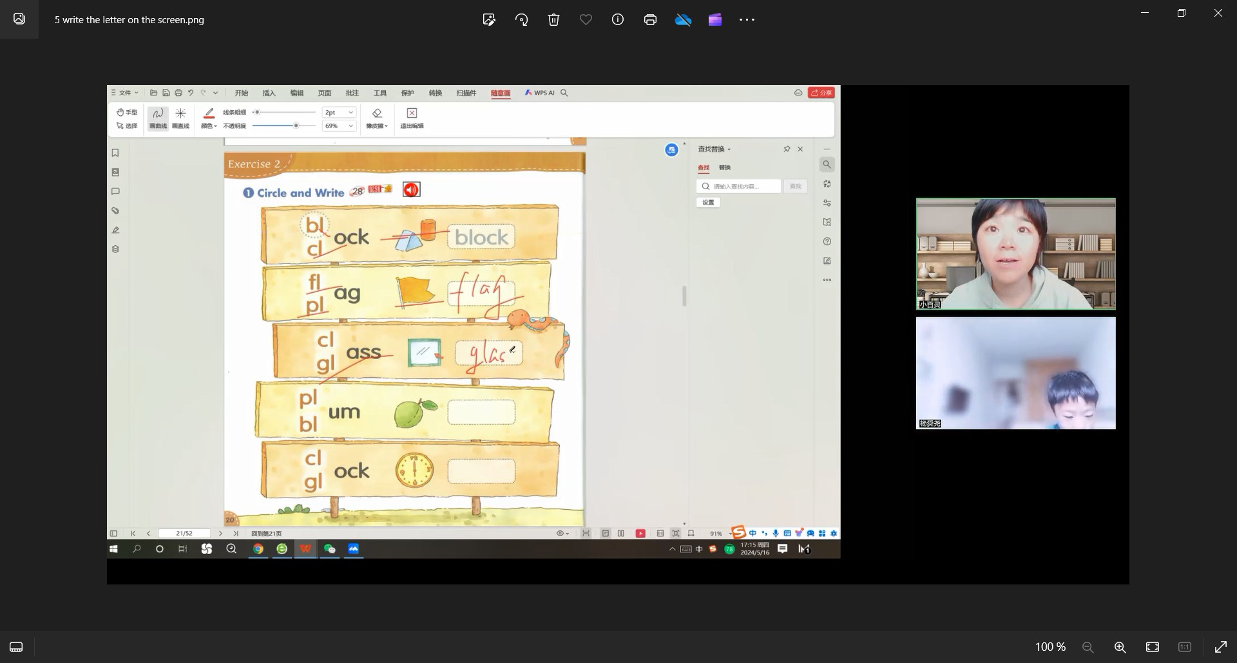

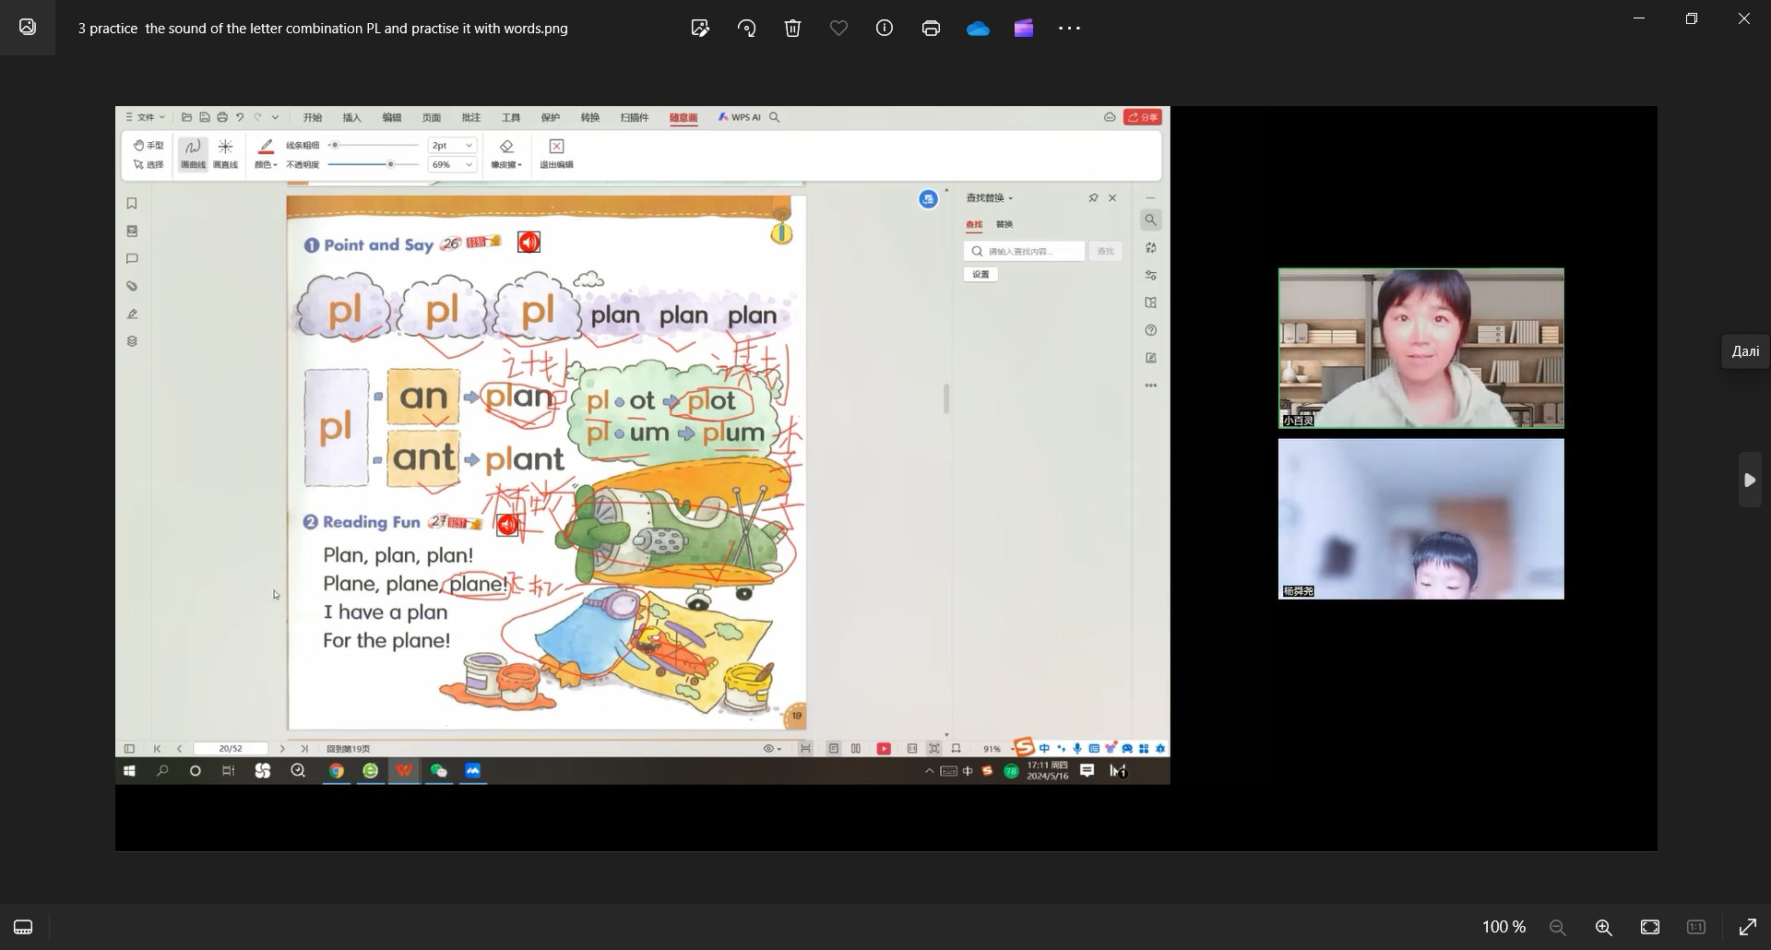

Figure 1. Episodes of flipped learning enhanced with interactive discussions

As we mentioned above, gamification focused on incorporating games such as language quizzes and virtual escape rooms into the curriculum has shown to increase students’ engagement and make learning more enjoyable.

For example, during a Tencent Meeting (Zoom) session, the teachers can use platforms like *Kahoot!* to conduct language quizzes where students compete in real-time. Being a game-based learning platform, Kahoot may be used to review students' knowledge and assess them or as a break from conventional classroom activities. Students join the quiz using their devices, and the instructor shares the quiz screen during the Tencent Meeting (Zoom) session. Questions appear one by one, and students earn points for correct answers and quick responses. The leader board is displayed after each question, adding an element of competition into training practice. This activity makes vocabulary and grammar review engaging and provides immediate feedback, helping students identify areas for improvement.

One more efficient tool to enhance gamification with interactivity is online environment Classcraft. It allows maintaining gamification approach involving trainees into going through the learning content individually or within the group, doing exercises, tests, and quests, and earning game bonuses of different kinds.

In order to add interactivity into this gamified learning, there was arranged the role playing game within Classcraft which involved individual students into the team role game, when each learner should choose a character (a Wizard, a Warrior, or a Healer) with certain skills, and do the quests (tests) cooperatively. The quests are prepared regarding the didactic purpose of educational content.

Overcoming the quests in the team, each trainee uses their character’ skills and is eager to contribute the best into the general team results, doing the tasks and earning

different bonuses (Gold Pieces, Experience Points, Health, Crystals and others) which help their team to get best learning results.

Thus, these and similar activities not only make learning fun but also provide immediate feedback, encouraging students to improve their language skills. Besides, the students are aware of their personal responsibility for the team common success, which definitely raises their motivation to learn better and contribute more to feel the pride of their team result.

Digital storytelling can be successfully enhanced with collaborative projects. Students are offered to create digital stories in groups, sharing their work with peers and receiving feedback. During an online class, students can use tools like Google Slides (Slidesgo or Adobe Spark) to collaboratively create digital stories combining text, images, and audio narrations. They can then present their stories during live sessions and engage in peer feedback. This method enhances their writing and speaking skills while promoting teamwork and creativity. Collaborative digital storytelling also allows students to express their ideas and experiences in an entertaining and meaningful way. The collaborative nature of the task also promotes teamwork and communication, which is beneficial for language mastering.

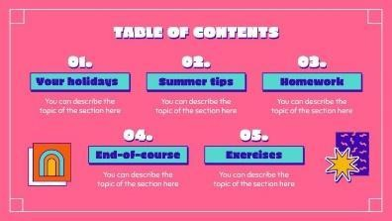For instance, the students are offered to create a digital group story “Happy holidays”. They are provided with a template of their digital story (episodes are given in figure 2) where each student (or a pair) are assigned a slide with prompts and have to respond to the prompts involving their holiday events, impressions, wishes etc. Then each group “tells” their story with the following up question-answer sessions. Final slideshow can be saved as a digital book to be used again as a learning aid created by the peers.



Figure 2. Episodes of a template for a digital group story “Happy holidays” (Slidesgo, 2022).

Cooperative learning can be used through group projects in terms of project-based online learning. Assigning group projects where students work together to achieve common goals promotes interaction and collaboration. In a Tencent Meeting (Zoom) class, the instructor assigns different roles to each group member and set clear objectives for the project. Minding PBL culture, the trainees’ opinion is taken into account, which allows them to make some decisions about the project (specify the topic of the project, decide what exactly to create, which digital tools to apply).

For example, senior students can work on a research project related to English-speaking cultures and present their findings to the class. The trainees are divided into groups, and each group is assigned a country to research.

The stages of work are organized according to the best practices recommended in the PBL guidelines, depicted above. During Zoom sessions, the students use breakout rooms to collaborate on gathering information and creating a presentation demonstrating the results of their research.

PBL is enhanced with interactive methods. Within the groups, there were organized argumentized discussions by the tutor to provoke students’ speaking and come up with ideas. For instance, the students were encouraged to answer the following questions:

1. Who are potential target audience of the project result?
2. What tasks are to be solved to create the project?
3. What are the peculiarities of the country and what information do you need to learn?
4. How to collect the said information?
5. How can the collected information be presented?

Finally, each group presents their findings to the class, and classmates ask questions and provide feedback. This project promotes cooperative learning, research skills, and public speaking.

This approach encourages trainees to communicate and collaborate effectively, enhancing their language skills, fostering a sense of community, and raising their motivation to learn.

Therefore, it is intuitively clear that the depicted techniques for foreign language learning could have positive impact on the students’ learning motivation due to their high involvement into the language using within real-life tasks and situations. However, to evaluate the level of the students’ motivation to learning, it was prepared the survey according to certain criteria to detect the levels of their revealing.

As it was mentioned above, according to psychological fundamentals of motivation theory and its educational aspects, motivation to learn foreign language is defined as a contributor to trainees’ achievements, progress of language mastering, enthusiasm in overcoming learning difficulties and retention in language non-formal education.

Among the most influential factors which affect student’s motivation are called interest to learning, empowerment and usefulness of language mastering, success, and satisfaction. Resting on this understanding of the student’s motivation to learn language, and minding certain rules for design of tutorial process regarding motivation raising, there were revealed several indicators and their levels presented below.

The said rules were presented in the theoretical framework section above and can be formulated in brief as follows: (1) to apply different learning strategies to provoke interest to language activities and attract trainees’ attention; (2) to give clear instructional goals and to focus trainees on the usefulness of language mastering in terms of their previous and potential experience; (3) to create the learning environment which promotes their positive attitude to the learning and suggests focusing towards success; (4) to help students gain satisfactory feeling. Therefore, instructors have to follow these rules in order to efficiently motivate students to study and master

languages.

Thus, the survey was created to evaluate whether the offered interactive techniques of language learning are in line with the mentioned rules for design of tutorial process and detect the students’ motivation levels.

The elaborated survey consists of 20 items embracing 4 subsections in accordance with the number of the rules. Each subsection embraced five items to receive feedback from the trainees on each motivation dimension. It enables to measure their motivation level using a 5 – point Likert-type scale (1 is strongly agree; 5 is strongly disagree).

To get preliminary outcomes and test the reliability of the survey, it was held in some groups of a Chinese private institution, “New Oriental Education Technology Group”. In total 27 students of senior grades who learned English online in terms of implementation of various blended learning activities enhanced with interactive methods depicted above. The survey was posted on the forums of distant learning system used in the institution. Thus, the survey participants were the trainees who granted their consent to do it. There were 15 female and 12 male participants, and their age ranged from 13 to 16.

The scale reliability test was held to estimate the outcome. The reliability of all scales (for each motivation dimension) on standardized Cronbach Alpha was 0.75 (n=27 on 20 items), which justified an acceptable reliability of the achieved outcome (Glen, 2020).

The average score of the learners’ motivation level as for four motivation dimensions, detected during the survey, is given in Table 1.

*Table 1*

# The average score of the learners’ motivation level (n=27)

Motivation dimensions

Average score

(5 items each) Interest to learning 3.43

Empowerment and

usefulness of language mastering

3.62

|  |  |
| --- | --- |
| Success | 3.61 |
| Satisfaction | 3.65 |
| Overall (20 items) | 3.57 |

In accordance with the score intervals, there were distinguished four levels of motivation:

High level (4.0-5.0),

Intermediate level (3.5-3.99),

Pre-intermediate level (3.0-3.49), Low level (less than 3.0).

The outcomes of the survey, according to the levels of the learners’ motivation, are demonstrated in the Table 2.

*Table 2*

# The learners’ motivation level as an outcome of the survey

|  |  |  |
| --- | --- | --- |
| Motivation  Level | Total  N=27 | Percent. |
| High | 14 | 51.9% |
| Intermediate | 8 | 29.6% |
| Pre-Interm. | 2 | 7.4% |

Low 3 11.1%

Therefore, according to the table 2.14 (51.9%) out of the 27 respondents revealed high level of motivation, 8 students (29.6%) demonstrated intermediate motivation level, 2 respondents (7.4%) revealed pre-intermediate level of motivation, and 3 respondents (11.1%) demonstrated low motivation levels.

Thus, it can be concluded that the survey participants were mostly satisfied with the blended learning practices enhanced with interactive methods, with over half of the respondents who had high and intermediate level of motivation to learn English as a foreign language.

The obtained outcomes of the survey are also coordinated with the educator’ observations of the learners’ behaviour, results of their work, and their informal feedback. In particular, about 85% of learners reported their increased engagement in interactive activities compared to conventional online English lessons. 78% of

respondents admitted that they felt more motivated to learn English when interactive techniques were used. Finally, about 90% of learners appreciated the involvement into interactive tasks, stating that they made English learning more enjoyable and effective.

# CONCLUSIONS

The article treats the currently important issues of foreign language mastering in China and the challenges of online English learning in terms of non-formal institutions.

Based on the recent studies and educational practice analysis, it is revealed the urgency of the research associated with the problems of dropping students’ motivation to learn foreign language, and the lack of a classroom environment that facilitates interactive and communicative language practice, which causes the necessity to find out efficient means of the students’ involvement into the interactive and practically driven forms of work. Minding the great potential of existing blended learning activities and interactive techniques, there was undertaken the attempt to engage the students of Chinese non-formal institutions in innovative foreign language practices during online classes.

According to the goals of the work, it is explored and elaborated on how interactive techniques can be applied to enhance typical blended learning activities in online English learning as a second language. This study also provides detailed examples of interactive methods applied in Chinese non-formal institutions in terms of typical online learning activities. Besides, it offers a preliminary analysis of the impact of these techniques on students' learning motivation.

It is also highlighted the preparation stage of the survey on the estimation of the learners’ motivation as an impact of the said activities. The survey consists of 20 items embracing 4 subsections matching the revealed motivation dimensions (interest to learning, empowerment and usefulness of language mastering, success, and satisfaction).

To get preliminary outcomes and test the prepared survey reliability, it was held in some groups of a Chinese private institution, “New Oriental Education Technology Group”. In total 27 students of senior grades who learned English online in terms of

implementation of various blended learning activities enhanced with interactive methods depicted above. The acceptable reliability of the scales was proved. The outcomes of the survey, according to the levels of learners’ motivation, are presented and discussed. There were also given and discussed the outcomes of the authors’ observations.

It was concluded that the obtained results of the conducted survey may be used potentially as a basis for holding the comprehensive empirical research for the verification of the impact which made the offered activities on the level of trainees’ motivation to learn a foreign language.

These findings suggest that further exploration and implementation of interactive techniques are warranted to enhance the quality of online English learning. It is planned to widen respondents’ range to generalize the survey outcomes and to expand it by specifying the changes caused by the introduced methods, where the prospects of our work lie.

# REFERENCES

Adel A., & Dayan J. (2021) Towards an intelligent blended system of learning activities model for New Zealand institutions: an investigative approach, Humanities and social sciences communications, 8:72 DOI: https://doi.org/10.1057/s41599-020-00696-4

Aljuaid, H., (2021). Students’ Motivation to Learn English as a Foreign Language in the Context of Saudi Arabian Learners. Arab World English Journal, 12 (3), 242-256. https://dx.doi.org/10.24093/awej/vol12no3.17

Batubara, T., Derin, N., Putri, R., & Yudar, (2020). Five Factors Influencing the Students’ Motivation to Learn English as a Foreign Language: A Closer Look into Montessori Classroom Environment. REiLA: Journal of Research and Innovation in Language, 2(2), 76-84. https://doi.org/10.31849/reila.v2i2.3165

Bergmann, J., & Sams A. (2012). Flip your classroom: Reach every student in every class every day.

International Society for Technology in Education.

Chen, H., & Hwang, G. (2020). Effects of using blended learning and interactive e-books on improving learning performance in a local culture course. Computers & Education, 146, 103782

Collie, R., & Martin, A. (2019). Motivation and Engagement in Learning. URL: https://doi.org/10.1093/acrefore/9780190264093.013.891.

Dellatola, D., Daradoumis, T., & Dimitriadis, D. (2020). Exploring students’ engagement within a collaborative inquiry-based language learning activity in a blended environment, Emerging

Technologies and Pedagogies in the Curriculum. Springer, Singapore, pp 355–375.

Dias, M. & Brantley-Dias L., (2018). Setting the standard for project based learning: a proven approach to rigorous classroom instruction, Interdisciplinary Journal of Problem-Based Learning 11. doi:10.7771/1541-5015.1721.

Dichev, C., & Dicheva D. (2017). Gamifying education: what is known, what is believed and what remains uncertain: a critical review, in: International Journal of Educational Technology in Higher Education, 14. https://dx.doi.org/10.1186/s41239-017-0042-5

Filgona, J., Sakiyo, J., Gwany, D., & Okoronka, A. (2020). Motivation in learning, Asian Journal of Education and Social Studies, 10, 16-37. https://dx.doi.org/10.9734/AJESS/2020/v10i430273.

Glen, S. (2020). Cronbach’s Alpha: Definition, Interpretation, SPSS. [https://www.statisticshowto.com/proba](http://www.statisticshowto.com/proba) bility-and-statistics/statistics- definitions/cronbachs-alpha-spss.

González S., & Bonal X. (2021). COVID‐19 school closures and cumulative disadvantage: Assessing the learning gap in formal, informal and non‐formal education, European journal of education, 56(4), 607-622. https://doi.org/10.1111/ejed.12476

Herpratiwi, A., Tohir, A. (2022). Learning interest and discipline on learning motivation, International Journal of Education in Mathematics, Science, and Technology (IJEMST), 10(2), 424-435. https://doi.org/10.46328/ijemst.2290.

Hui, Y.K., Li, C., Qian, S. et al. (2019). Learning engagement via promoting situational interest in a blended learning environment. J Comput High Educ 31, 408–425. https://doi.org/10.1007/s12528-019-09216-z

Jiang, H., Islam, A. Y. M. A., Gu, X., & Spector, J. (2021). Online learning satisfaction in higher education during the COVID-19 pandemic: A regional comparison between Eastern and Western Chinese universities. Education and Information Technologies, 26(6), 6747–6769. https://doi.org/10.1007/s10639-021-10519-x

Le T., (2018). Project-based learning in 21st century: a review of dimensions for implementation in university-level teaching and learning, Proceedings of 4th ICEAC International Conference on English Across Cultures 230-241.

Lemeshchenko-Lagoda, & V., Kryvonos, I. (2020). Interactive means of motivating students to learn English for specific purposes at agrarian and technical universities, Educational Dimension, 3

pp. 233–250. https://doi.org/10.31812/educdim.v55i0.3950.

Li, H., Peng, M., Yang, M., & Chen, C. (2020). Exploring the influence of learning motivation and socioeconomic status on college students’ learning outcomes using self-determination theory, Front. Psychol, 11, 849 https://dx.doi.org/10.3389/fpsyg.2020.00849.

Mohammed, M., & Muesser, N. (2019). Blended learning motivation model for instructors in higher education institutions, International Journal of Educational Technology in Higher Education 16,

12. https://doi.org/10.1186/s41239- 019-0145-2.

Paul, R., & Elder, L. (2006). The miniature guide to critical thinking: Concepts and tools. Foundation for Critical Thinking. URL: [https://www.criticalthinking.org/files/Concepts_Tools.pdf](http://www.criticalthinking.org/files/Concepts_Tools.pdf)

Ren, W., Wang, R., & Nor, S. (2024). Factors influencing students' learning satisfaction and students' learning outcomes in blended learning, International Journal of Education and Practice, 12 (1). 95-108. https://dx.doi.org/10.18488/61.v12i1.3624.

Rubrica R., (2019). An action research of project based learning and understanding by design and their effects on the science achievement and attitude of science students. [https://www.academia.edu/39644033.](http://www.academia.edu/39644033)

Rutta, C., G. Schiavo, M. Zancanaro, & E. Rubegni, (2021). Comic-based Digital Storytelling for Content and Language Integrated Learning, Educational Media International, 58(1), 21-36, https://dx.doi.org/10.1080/09523987.2021.1908499

Sagri, M., Sofos, F., & Mouzaki D. (2018). Digital Storytelling, comics and new technologies in education: review, research and perspectives The International Education Journal: Comparative Perspectives 17(4)97-112. https://openjournals.library.sydney.edu.au/i ndex.php/IEJ

Shaiful I. at al, (2018). To boost students’ motivation and achievement through blended learning, Journal of Physics: Conference Series 1114 012046.

Slidesgo, (2022).

https://slidesgo.com/theme/happy-summer-holidays#search-Holidays&position-13&results-402

Triarisanti, R., & Purnawarman, P. (2019). The influence of interest and motivation on college student’s language and art appreciation learning outcomes, International Journal of Education, 11(2) 130-135. https://dx.doi.org/10.17509/ije.v1.14745.

Trivedi, N., & S. Mohanti (2019). Significance of Project-based Learning in Education, JETIR 6 (2), 339-344. [www.jetir.org.](http://www.jetir.org/)

Wright, A., Betteridge, D., & Buckby, M. (2006). Games for language learning (3rd ed.). Cambridge University Press.

Zainuddin, Z., Chu, S.K.W., Shujahat, M., & Perera, P. (2020). The impact of gamification on learning and instruct tion: A systematic review of empirical evidence, Educational Research Review, 30 100326. https://dx.doi.org/10.1016/j.edurev.2020.100326

Zhou L., Wang T. (2020). The effect of online learning on students’ performance: Evidence from a large-scale random assignment experiment, Computers & Education, 157, 103966.

**ІНТЕРАКТИВНІ МЕТОДИКИ ВИВЧЕННЯ ІНОЗЕМНИХ МОВ ОНЛАЙН У НЕФОРМАЛЬНИХ НАВЧАЛЬНИХ ЗАКЛАДАХ КИТАЮ**

***Людмила Гризун,*** *доктор педагогічних наук, професор кафедри інформаційних систем Харківського національного економічного університету імені С. Кузнеця, просп. Науки, 9А, 61070, Харків, Україна,* [*Lgr2007@ukr.net*](mailto:Lgr2007@ukr.net)

***Цайджин Чжан****, аспірантка кафедри педагогіки, іноземної філології та перекладу Харківського національного економічного університету імені С. Кузнеця, просп. Науки, 9А, 61070, Харків, Україна,* [*zcj399489@163.com*](mailto:zcj399489@163.com)

*У статті розглядаються актуальні на сьогодні проблеми опановування іноземною мовою в Китаї та виклики онлайн-вивчення англійської мови в умовах закладів неформальної освіти. Виявлено актуальність дослідження, пов’язану з проблемами зниження мотивації студентів до вивчення іноземної мови, а також відсутністю освітнього середовища, яке б сприяло інтерактивній та комунікативній мовній практиці, що зумовлює необхідність пошуку ефективних засобів навчання студентів, залучення їх до інтерактивних та практично орієнтованих форм роботи. Враховуючи значний потенціал існуючих видів навчальної діяльності при змішаному навчанні та інтерактивних методів, було зроблено спробу залучити студентів китайських закладів неформальної освіти до інноваційних практик іноземної мови під час онлайн-занять. Відповідно до цілей роботи, досліджено та детально описано, як доцільно застосовувати інтерактивні методи для покращення типових видів змішаної навчальної діяльності в онлайн-вивченні англійської мови як іноземної. У цьому дослідженні також представлені приклади інтерактивних методів, які застосовуються в китайських неформальних закладах з точки зору типової навчальної діяльності в онлайн умовах. Крім того, проведено попередній аналіз впливу цих прийомів на навчальну мотивацію студентів шляхом підготовленого опитування. З метою перевірки надійності опитування, воно було запропоновано в кількох групах китайського приватного закладу. Загалом опитуванням було охоплено 27 учнів старших класів, які вивчали англійську мову в режимі онлайн за допомогою різноманітних змішаних навчальних технік, доповнених інтерактивними методами, описаними в роботі. Доведено прийнятну надійність розробленого опитування. Представлено та проаналізовано результати опитування за рівнями навчальної мотивації учнів.*

***Ключові слова****: онлайн вивчення іноземної мови, неформальні заклади освіти Китаю, залучення студентів, інтерактивні методи, техніки змішаного навчання, мотивація до навчання.*

Received: 28.11.2024

Accepted: 10.12.2024